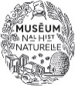

Call for Papers
International conference

Caging the sky: art, history and anthropology
of aviaries

Rome, February 6-8, 2020
Académie de France à Rome – Villa Médicis
Sapienza – Università di Roma, Facoltà di Architettura

1 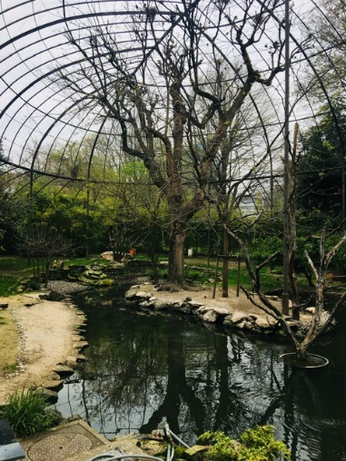 2

3 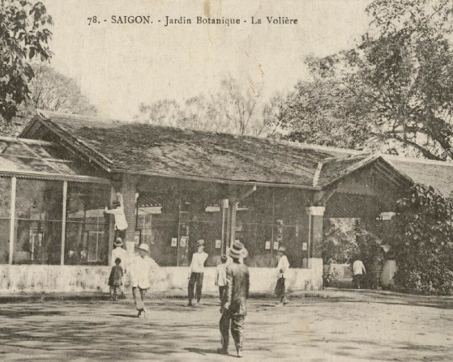 4

Presentation
Deeply rooted in the long history of technology, architectural construction, and the domestication and acclimatisation of animal species by humans, aviaries are an interdisciplinary research subject offering multiple approaches for studying both past and present bonds, connecting societies to their environment, to explore the place of birds in the collective imaginary, but also to appreciate the originality of works or constructions that were conceived in order to represent, signify or house animal life.
Designed mainly for the breeding, exhibition and conservation of birds in captivity, aviaries have historically taken a multitude of forms. Unlike cages, which are smaller mobile objects, aviaries are veritable constructions which are sit in a framework of architectures and landscapes. These hybrid and polymorphic structures present large perforated spaces, which allow them to function simultaneously as open buildings, places of captivity and for the presentation of animal collections. Aviaries are also sizeable enough to allow short distance flights: they make a spectacle of the flight of birds for the external observer and tend to celebrate the captivity of animals as a state of “semi-freedom”.
These spatial and material compositions that shelter, organise and present a community of living beings, possess a metaphorical potential which often makes them vectors for a wide variety of concepts, practices and images. Domestic, zoological, cynegetic, ornamental aviaries shed light on representations of nature and the place of human beings therein, as well as on moral conceptions, social hierarchies, scientific paradigms. They reveal the dynamics of circulation of things, living beings, knowledge and ideas within societies and between cultures, as well as the underlying power relations.
The goal of this international conference is to explore the primary perspectives, fields and topics of an interdisciplinary research on aviaries. It will also attempt to define materials, objects and investigation methods, and to instigate new interpretations through unpublished works, supported by original methodologies.
Participants are invited to consider this research topic following three main research perspectives:
1/ Aviaries as material structures and devices: constructions, sensorial experiences and aesthetics of the living world.
The first research perspective considers the different functions assigned to aviaries – productive, ornamental, musical, scientific, etc. – starting with a thorough review of techniques, devices and operating methods. It concerns architectural design, spatial, visual and acoustic properties, but also physical techniques, the relations they create between humans and animals, and the kinds of sensorial experience and affectivity.
2/ Caged birds, birds in collections: from predation to conservation
The second research perspective considers aviary birds as livestock, but also as collectable objects. It seeks to identify species, to analyse hunting and transportation methods, to follow the geopolitics of procurement, to understand the logic of accumulations, classification and categories: edible birds, songbirds or birds of prey, local or exotic species, objects of delight or affection, scientific or heritage specimens…

3/ Aviaries as symbolic systems: conceptions of nature, moral allegories, incarnations of power.
The third research perspective considers aviaries from the point of view of representations, ideas and values. From spiritual conceptions to scientific paradigms, over time aviaries recompose the configurations of living beings and the conceptions of nature: aviaries show the way to link the different entities which constitute them and to positioning oneself as a human being therein. Their study unveils beliefs, cosmogonies, as well as épistémès. It emphasises power structures within and among societies, particularly concerning access to and control of wildlife resources.
Talks may take the form of monographs, regional surveys, thematic and/or transversal research, but also technical, methodological or epistemological propositions. The overall approach is open to humanities, sciences and mediation of natural and cultural heritage, in order to free the heuristic power and the didactic value of this caged nature.
Disciplines concerned: architecture, history of architecture and of the arts, history of landscaping and gardens, anthropology of nature and living beings, historical anthropology, heritage studies, collecting studies, museum studies, gender studies, postcolonial studies, cultural history, social history, scientific history, history of techniques, scenography, literature, musicology, archaeology of sound, archaeozoology, life science, ornithology, ethology, animal studies.
Keywords: aviaries – cages – birds – captivity – hunting – gardens – landscapes – nature.
Conference organisation
Talks may be in Italian, French and English. They will be limited to 25 minutes.
Papers presented at the conference will be reviewed for a possible publication in a collective scientific volume.

Submissions
Proposals must be submitted, via e-mail, before 4th July 2019, to the following address: patrizia.celli@villamedici.it
They must include a title, a summary of 2500 characters maximum (spaces included), and a biographical presentation of 1000 characters.
Candidates will be informed of the selection around Monday, 15th July 2019 via e-mail.

Organizers: Francesca Alberti Académie de France à Rome – Villa Médicis ; Flaminia Bardati Sapienza – Università di Roma ; Julien Bondaz Université Lumière Lyon 2 ; Emmanuel Lurin Sorbonne Université/Centre André Chastel ; Mélanie Roustan Muséum national d’histoire naturelle.
Coordination : Patrizia Celli Académie de France à Rome – Villa Médicis.

Comité scientifique : Baudouin van den Abeele Université catholique de Louvain/FNRS ; Adrian van Allen California Academy of Sciences, Berkeley ; Etienne Anheim (EHESS, Paris) ; Damien Baldin (EHESS, Paris) ; Cyrille Bret Haute École des Arts du Rhin, Mulhouse et Strasbourg ; Hervé Brunon Sorbonne Université/CNRS, Paris ; Alberta Campitelli Vicepresidente dell’Associazione parchi e giardini d’Italia, Roma ; Claudia Cieri Via Sapienza – Università di Roma ; Allen Grieco Harvard Center for Renaissance Studies, Villa I Tatti, Firenze ; Frédéric Keck CNRS/Laboratoire d’anthropologie sociale, Paris ; Guy Lambert École nationale d’architecture Paris-Belleville ; Frédéric Laugrand Université Laval, Québec ; Iris Lauterbach Technische Universität, München ; Corinne Le Bitouze Bibliothèque nationale de France, Paris ; Vanessa Manceron CNRS/LESC, Paris ; Anne Monjaret CNRS, Laboratoire IIAC-LAHIC, Paris ; Monique Mosser Sorbonne Université/CNRS, Paris ; Mauro Mussolin Kunsthistorisches Institut in Florenz – Max Planck Institut ; Natsumi Nonaka Illinois State University, Normal ; Patrizia Tosini Università degli Studi di Roma Tre ; Anne-Gaëlle Weber Université d’Artois, Arras.

1. Paris, Jardin des Plantes, Grande volière, vue actuelle - cliché Mélanie Roustan.
2. Giovanni Battista Falda, Orti Farnesiani (détail), 1685, eau-forte – collection particulière
3. Saïgon, Jardin Botanique - La volière (détail), vers 1900, carte postale - collection particulière.
4. Johann Jakob Walter, Crécelle (détail), milieu du XVIIe siècle, aquarelle et gouache sur papier - Strasbourg, Cabinet des estampes et des dessins.

